# Ideation Phase

**Brainstorm & Idea Prioritization Template**

|  |  |
| --- | --- |
| Date | 30 October 2023 |
| Team ID | NM2023TMID08618 |
| Project Name | TRANSPARENT EDUCATION DATA MANAGEMENT |
| Maximum Marks | 4 Marks |

## Brainstorm & Idea Prioritization Template:

Brainstorming provides a free and open environment that encourages everyone within a teamto participate in the creative thinking process that leads to problem solving. Prioritizing volume over value, out-of-the-box ideas are welcome and built upon, and all participants are encouraged to collaborate, helping each other develop a rich amount of creative solutions.

Use this template in your own brainstorming sessions so your team can unleash their imagination and start shaping concepts even if you're not sitting in the same room.

Reference: <https://www.mural.co/templates/empathy-map-canvas>

## Step-1: Team Gathering, Collaboration and Select the Problem Statement

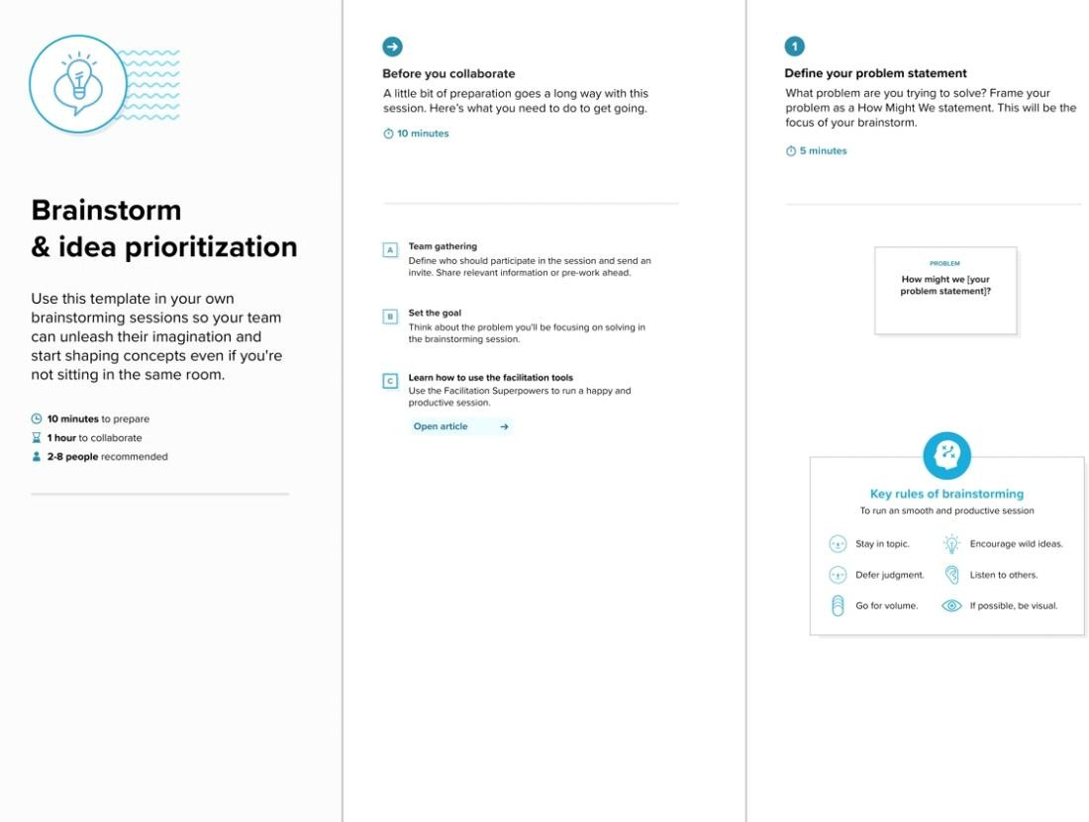

### Step-2: Brainstorm, Idea Listing and Grouping

##### Before you collaborate

A little bit of preparation goes a long way with this session. Here’s what you need to do to get going.

**1**

##### Choose your best "How Might We" Questions

Share the top 5 brainstorm questions that you created and let the group determine where to begin by selecting one question to move forward with based on what seems to be the most promising for idea generation in the areas you are trying to impact.

**2**

##### Brainstorm solo

Have each participant begin in the "solo brainstorm space" by silently brainstorming ideas and placing them into the template. This "silent-storming" avoids group-think and creates an inclusive environment for introverts and extroverts alike. Set a time limit. Encourage people to go for quantity.

**3**

##### Brainstorm as a group

Have everyone move their ideas into the "group sharing space" within the template and have the team silently read through them. As a team, sort and group them by thematic topics or similarities. Discuss and answer any questions that arise. Encourage "Yes, and…" and build on the ideas of other people along the way.

**4**

##### Decide your focus

**TIP**

You can use the **Voting session** tool above to focus on the strongest ideas.

Give each person two icons to vote which idea should your team focus on.

##### After you collaborate

A brainstorm like this typically results in a handful of promising ideas that you can carry forward and act upon.

# Conducting a brainstorm

Executing a brainstorm isn't unique; holding a productive brainstorm is. Great brainstorms are ones that set the stage for fresh and generative thinking through simple guidelines and an open and collaborative environment. Use this when you're just kicking-off a new project and want to hit the ground running with big ideas that will move your

team forward.

**15 minutes** to prepare

**30-60 minutes** to collaborate

**3-8 people** recommended

[Created in partnership with](https://about.facebook.com/)

**15 minutes**

**A Choose your best "How Might We" Questions**

Create 5 HMW statements before the activity to propose them to the team.

**B Set the stage for creativity and inclusivity**

Go over the brainstorming rules and keep them in front of your team while brainstorming to encourage collaboration, optimism, and creativity.

1. **Encourage wild ideas** (If none of the ideas sound a bit ridiculous, then you are filtering yourself too much.)
2. **Defer judgement** (This can be as direct as harsh words or as subtle as a condescending tone or talking over one another.)
3. **Build on the ideas of others** ("I want to build on that idea" or the use of "yes, and...")
4. **Stay focused on the topic at hand**
5. **Have one conversation at a time**
6. **Be visual** (Draw and/or upload to show ideas, whenever possible.)
7. **Go for quantity**

**C Interested in learning more?**

Check out the Meta Think Kit website for additional tools and resources to help your team collaborate, innovate and move ideas forward with confidence.

[**Open the website**](https://www.facebook.com/business/m/thinkkit/?ref-northstar)

**10 minutes**

**QUESTION**

**How might we... [insert problem statement here]?**

**10 minutes**

**Nandhaguru S**

**Data Privacy**

**Decentralized Ledger**

**Immutable Records**

**Verification and Authentication**

**Transparency and Auditability**

**Prakash J**

#### 

**Mobile Accessibility**

**Transparency and Auditability**

**Fraud Detection**

**Government and Regulatory Compliance**:

**User Support and Education**:

**Decentralized Identifiers (DIDs)**:

**Navaneetha Krishnan K**

#### 

**Government and Regulatory Compliance**:

**User Support and Education**:

**Fraud Detection**

**15 minutes**

**Fraud Detection**

**QUESTION**

**How might we... [insert problem statement here]?**

**Fraud Detection**

**User Support and Education**:

Fraud Detection

**Mobile Accessibility**

**Mobile Accessibility**

**User Support and Education**:

Fraud Detection

**5 minutes**

**Person 1 Person 2**

**Person 3 Person 4**

**Person 5 Person 6**

**Person 7 Person 8**

**QUESTION**

**How might we... [insert problem statement here]?**

**Quick add-ons**

**A Cluster related ideas**

Look for patterns or similarities in the standout ideas. Could any be combined together to form a stronger concept?

Cluster similar ideas and label each cluster with a theme.

**B Vote on the most promising ideas**

Narrow your focus to only the strongest few ideas by holding a **Voting Session**. Give each person 2 votes

###### Keep moving forward

**2x2 Prioritization matrix**

Build shared understanding and make collective decisions for moving ideas forward.

[**Open the template**](https://app.mural.co/template/f31a757a-3cb5-4dfc-8418-d4bfa63bf472/0674b2d1-439e-4b06-842a-714d6fc51171)

**Storyboarding**

Show existing and/or future consumer experiences through the act of sketching.

[**Open the template**](https://app.mural.co/template/4e8e017f-981f-4819-b2f3-351f6c972970/20d5762e-2839-4801-b0bc-4fc29b4cb3db)

**Pre-mortem**

Harness the collective experience and wisdom of the team, before the project even starts.

[**Open the template**](https://app.mural.co/template/ec90a918-7534-47ee-aafe-ceced364d176/0d38a9d9-8b0a-495a-8c59-81798d811226)

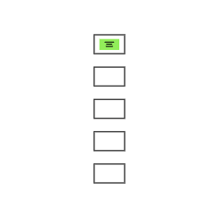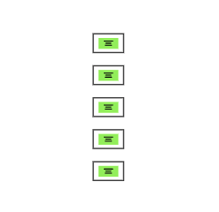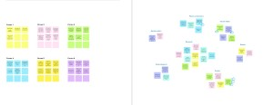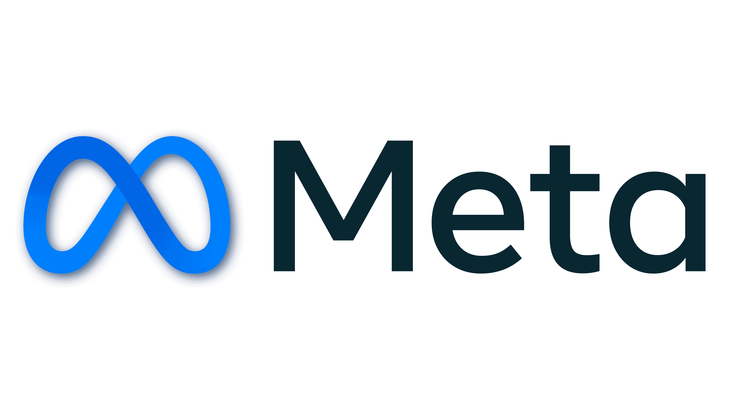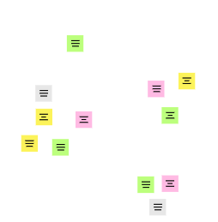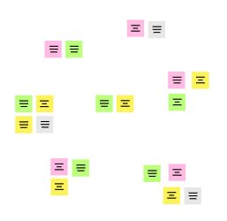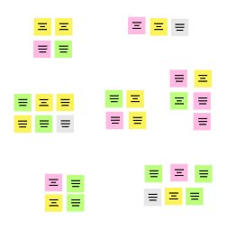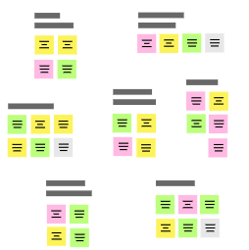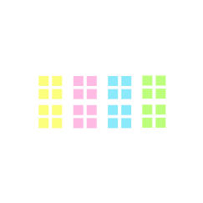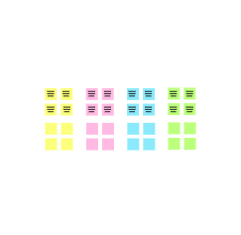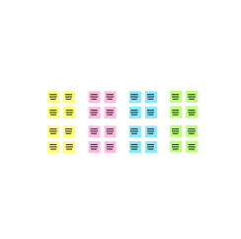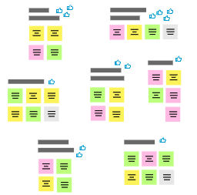

**Template**

[**Share template feedback**](https://muralco.typeform.com/to/CiqaHVat?typeform-source=app.mural.co)

**Government and Regulatory Compliance**:

**Government and Regulatory Compliance**:

**Mobile Accessibility**

**Decentralized Identifiers (DIDs)**:

**QUESTION**

**How might we... [insert problem statement here]?**

**QUESTION**

**How might we... [insert problem statement here]?**

**Need some inspiration?**

See a finished version of this template to kickstart your work.

[**Open example**](https://app.mural.co/template/d42717ab-e2ce-4ebc-a805-b0cccd51479d/0436e888-3331-42fe-8cc7-5028b525622e)

**Step-3: Idea Prioritization**